Tailor Maid Home Care
Care at Home Showcase July 2020
_____________________________________________________
As Scotland moves onto Phase 3 of the lockdown and restrictions are slowly lifted, we wanted to showcase some good news stories from Tailor Maid and to appreciate the carers who throughout the crisis have displayed great courage, compassion and commitment in supporting our clients and each other.All our staff have worked courageously and with passion to protect the health, safety and wellbeing of those in our care.
Care Director Shirley Dickson said:
“Never has there been a time when we have had so much to be grateful for in the Care Sector. I would like to thank everyone who has worked tirelessly in this challenging time when family and friends have been unable to visit loved ones at home.”
A tribute to Janet McCartney
_____________________________________________________
We wanted firstly, to pay tribute to one of our colleagues, Janet McCartney, who sadly passed away on 14TH July 2020 aged 34. Janet was an amazing Carer and during her time with TMHC she took great interest in finding out about her clients’ interests, participating in activities with them and brightening up their day with her sense of humour. She built up a great relationship with all their clients, familiarising herself with their daily routines. Janet was extremely well liked and was a valuable member of our team. It is a fitting tribute to Janet to be showcased and allow us to give thanks of her dedication and professionalism. She worked tirelessly to care for others. She will be sorely missed.
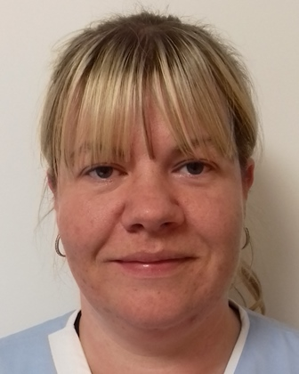
“My first impression of Janet was that she was a happy, bubbly, cheery, kind and thoughtful person with a great sense of humour. During the time she worked with TMHC I never saw her any other way.

She took each client to her heart and they likewise. It has since come to light that her clients kept in touch with her during the time she was off – such was their relationship and friendship.

She will always be remembered with a smile.”
~ Margaret Phillips, Supervisor

Client and Staff Achievements during lockdown - keeping life as normal as it could be.
_____________________________________________________
Sheila - Compassion
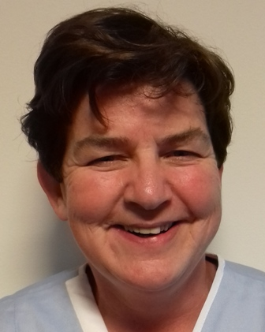 | Sheila one of our senior Carers was really helpful during the pandemic to one of her clients whose wife had sadly passed after she had been taken into Hospital. It was a difficult time for him and family with all the restrictions in place at the time. Sheila went above and beyond supporting him to deal with things required to be done prior to the funeral.  Thank you so much Sheila
Frances - Inclusion
Frances supported many clients be included using technology. She played lots of Vera Lynn tunes on her iPhone and got the clients to sing along with Frances!
Using her iPhone she brightened up clients days by using special filters on snapchat which superimposes your face onto different funny filters. This really made them laugh!
Claire - Occupation
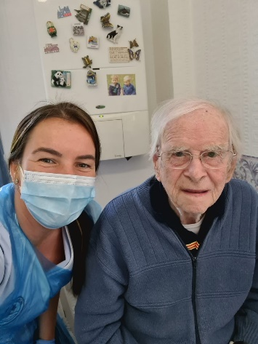 | Alex has always loved his garden and now with reduced mobility, his family have taken the garden indoors. Claire supported Alex during isolation, to continue to keep his tomato plants growing- so much so they extended to the ceiling!!  An extra haircut for some was also on the timetable as a member of staff used her previous hairdressing skills to give a trim to some of our gents during lockdown- using her PPE!

Client - Identity
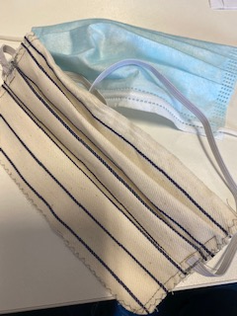 | One of our Clients put into practice her sewing skills by making a bag full of fabulous masks for all the staff to use off duty. She used a template of our surgical mask and got set to work. This supported her to engage in activities that validates who is she is. She felt respected as a unique individual who was helping to support our carers. Our carers surprised her with a lovely thank you card and chocolates.
Supervisor Team
Our Supervisors supported all clients during lockdown with regular telephone calls, visits and updates to keep them informed. Using IT they were able to keep in touch with families when they were unable to visit their loved ones.  Providing reassurance during COVID-19 enriched clients psychological needs with a comforting call and chat. They supported all our staff too. | 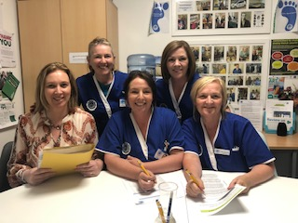
Collette - Attachment
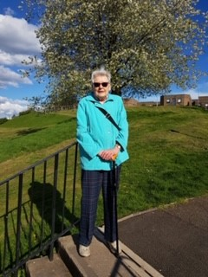 | Colette regularly supported her client Elizabeth go out on local walks around her home during lockdown. It was important for Elizabeth to feel connected to others and spend time with other people when safe to do so.  She really enjoyed the sunny weather during lockdown and kept up her daily step count.  Well done ladies

Angela
Angela has enjoyed playing chess with Gordon. Gordon has kept busy during lockdown by enjoying board games and other activities as part of his daily visit.  Engaging in activities is so important to clients – especially during lockdown. | 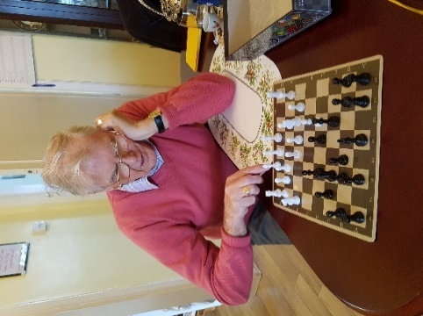
Sonya
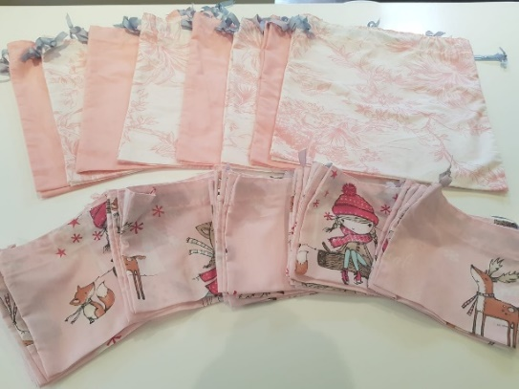 | Sonya and her friends were very busy during the pandemic. They asked our clients for old duvet covers and converted them into scrubs for the NHS, including using Peppa Pig for a special request for the sick kids in the Children’s Hospital.  Thank you Sonya!
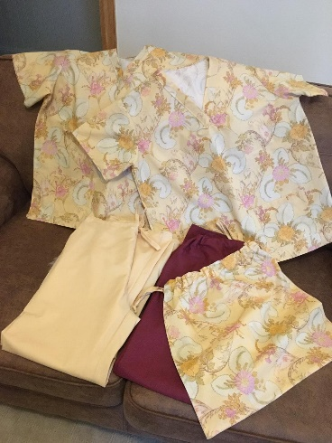 | 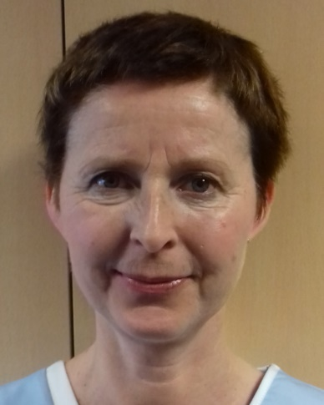
Linda Bell
Linda put her dress-making skills to good use over the pandemic and made a wonderful selection of masks for staff to wear off-duty.  Thank you so much! | 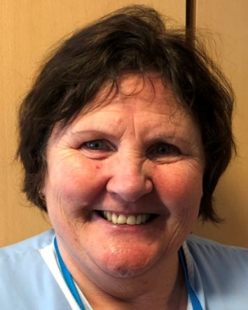

Staff with their “Mug with a Hug “
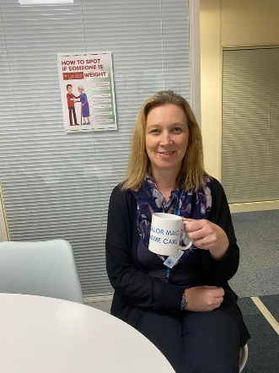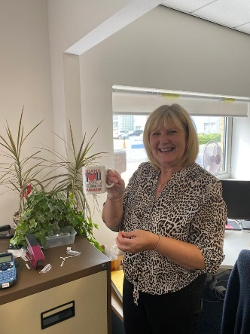
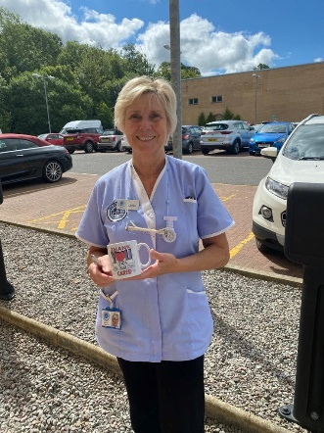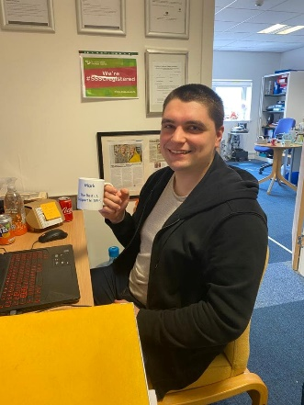
This month we gave all members of staff a mug with a hug to say thank you for all the hard work over the course of the pandemic – we appreciate how hard our staff have worked through this time!

Supporting Psychological Needs and Impact of Isolation
_____________________________________________________
During times of absence of family and friends due to COVID-19 Isolation, our staff have tried really hard to meet psychological needs of our clients and so meet their outcomes better. It is important that our clients to know that they have not been alone, and our team have worked really hard to brighten up their day with activities. We have addressed many needs and would like to showcase how we did that.
- Providing comfort during challenging times either through emotional or practical support has been upmost in our care.
- Being included with what’s happening in the world, recognising when they have been lonely and help me feel connected
- Identity-Supporting our clients to engage in activities and have access to things which are important to them and talk to clients about those interests
- Occupation-as in the roles that they have undertaken during their life-Staff have supported clients to be fulfilled in by how their time is spent
- Attachment- being recognised and valued as a unique person- staff have thought on creative ways that helped clients feel connected
inclusion
identity
comfort
keeping clients connected
caring
attachment
compassion
dedication
safe

